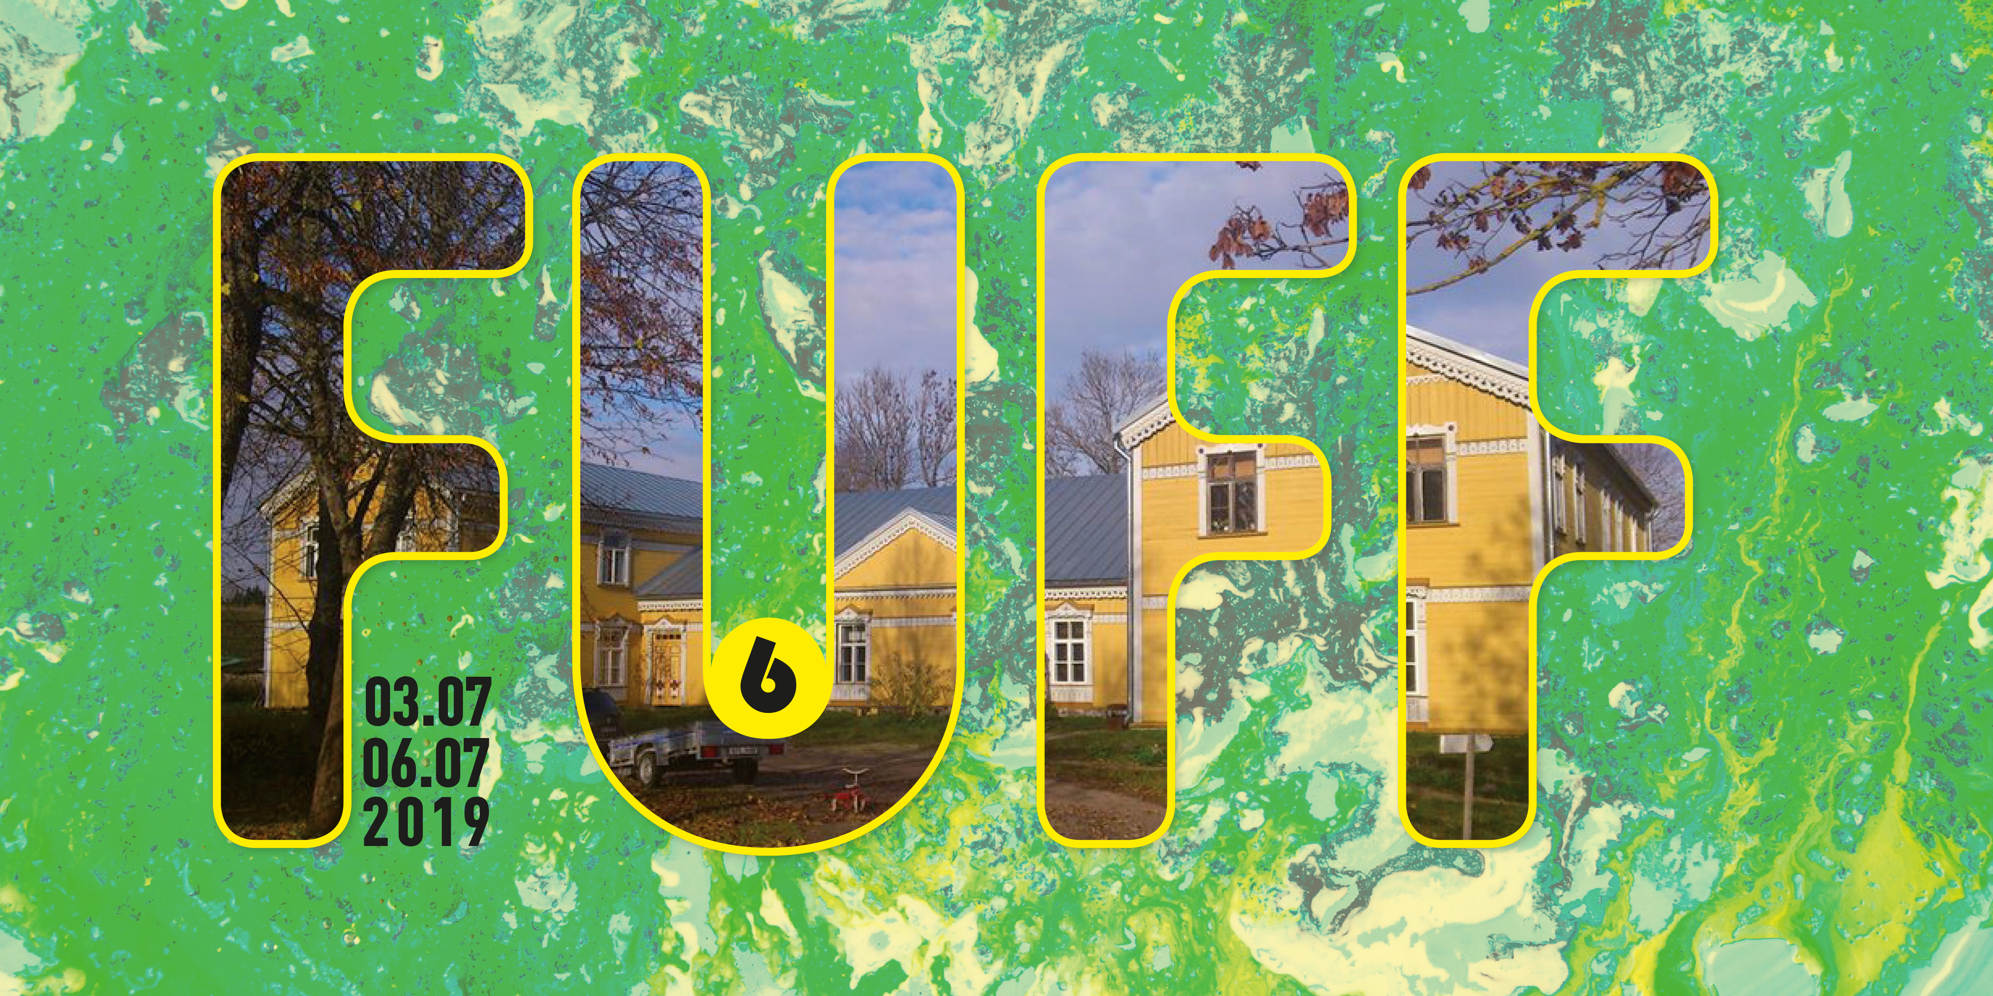

Workshop call!

The Finno-Ugric Film Festival VI will be held from the 3-6th of July 2019, and invites you to apply to the variety of workshops they offer. More info about the specific workshops below and at www.fuff.ee.
DEADLINE IS 15. of April 2019.

SCRIPTWRITING WORKSHOP
We invite 12 applications from filmmakers who wish to participate in this workshop.
The workshop will be held by two well-known film professionals/scriptwriters/directors DÁNIEL ERDÉLYI who will help to develop your synopsis into a short film script during the festival.Those selected will receive assistance as follows:
• For applicants from the Finno-Ugric small nations (Komi, Udmurt, Khanty, Mansy, Nenets, Enets, etc.) FUFF will reimburse travel expenses from Moscow as well as providing accommodation and food during the festival.
• In addition the invitation is open to filmmakers from other countries. For these applicants FUFF will provide food and accommodation during the festival.

EXPERIMENTAL FILM WORKSHOP
The Finno-Ugric Film Festival VI announces its Experimental Film Workshop, to be held during the Festival in Sänna, Estonia, 3th-6th JULY 2019.
We invite 4 NON Finno-Ugric directors from all over the world, to create their short films during the festival. The directors can invite max. 2 crew members they want to work on their project with.
Each film group or director will get a Finno-Ugric actor with whom they have to collaborate their projects on. The premiere of the films will be after the festivals closing ceremony.
The workshop is lead by Nándor Hevesi (Ivan Buharov director, HU)
Producer Dora Nedeczky will be holding a course about the role of the producer within experimental filmmaking, and also distribution opportunities. She'll be line-producing the projects during the Workshop. Dora is a Sundance, SXSW and Berlinale Shorts alumna producer from Hungary, active in the fields of observational and hybrid documentaries, fiction and experimental films as well as music videos since 2010. www.mindwax.eu"
Liis Nimik will be your editing tutor in the experimental workshop, giving you feedback on your cuts in various stages. She is a valued Estonian film editor with 4 feature films and numerous docs in her filmography. She is especially interested in the "unknown", "unexplainable" and "unexpected" in filmmaking and she is exploring those dark areas in her films and together with her international master students at BFM Kinoeyes MA program.

ANIMATION WORKSHOP
Possibility to make supershort animated films, trying different techniques animating under the camera. Computer helps only a little bit, we create the characters and backgrounds on the spot. In animation everything is possible! Necessary equipment and Helen Unt, Francesco Rosso and Anu-Laura Tuttelberg will be there to show how.
People with any age and background can participate, no need for previous experience. DOES NOT NEED REGISTRATION BEFOREHAND
Experimental musical workshop
In the workshop participants try to listen and explore surrounding environment. What kind of sounds there is to find? How does the silence sound? Can any abandoned objects around be used as instruments? How can we response to the call of the natural soundscape using our own voice and body as an instrument? These are the main questions we concentrate, and try to solve them in action during the workshop. Earlier experience around music is not necessary. People of all ages can participate the workshop with their personal presence. During the workshop we will find a common way to play simple rhythms, encourage ourselves to use our voices and natural presence powerfully. In the end these elements will be combined to create an orchestra or "big happening" of the participants.
Workshop is led by musician/composer Otto Eskelinen. He has graduated from Sibelius Academy folk music department and worked professionally over 15 years around Finnish music scene, making music for theatre, circus and other performing art forms. Since 2013 he has led ethnofuturistic ensemble "The Mystic Revelation Of Teppo Repo". The group has published three studio albums and made music to the documentary film "The Nature Of My Heart" 2016 (Jaakko Ruuska)). DEOS NOT NEED REGISTRATION BEFOREHAND

ANALOGUE WORKSHOP
First time at the festival's history, we will organise an analogue film workshop for the participants who are interested in analoguefilm making on 8mm or on 16mm. The participants can try different things with the leadership of a professional tutor. (We are still negotiating who will be this tutor)

HOW TO APPLY?

Scriptwriting workshop
In addition the invitation is open to filmmakers from other countries. For these applicants FUFF will provide food and accommodation during the festival.
Participation fee is 50 EUR / participant for the Non-Finno-Ugric participants
Send us a film proposal synopsis A4 and your motivation letter (A4) to sara.kisari@gmail.com by 15th of April 2019.
Decision will be made by the end of April.

Experimental Film Workshop and the ANALOGUE film workshop
Requirements
The selected participants has to take their equipment with which they create their films. FUFF will provide food and accommodation during the workshop.
Participation fee is 50 EUR / person
Send us your motivation letter (A4) to sara.kisari@gmail.com by 15th of April 2019. Decision will be made by the end of April.

MORE INFO www.fuff.ee

